Template 4.19 D

Vehicle Recovery Kit
- Two 4,750kg bow shackles
- One 8,000kg (Min. breaking strength) snatch strap
- One pair of gloves
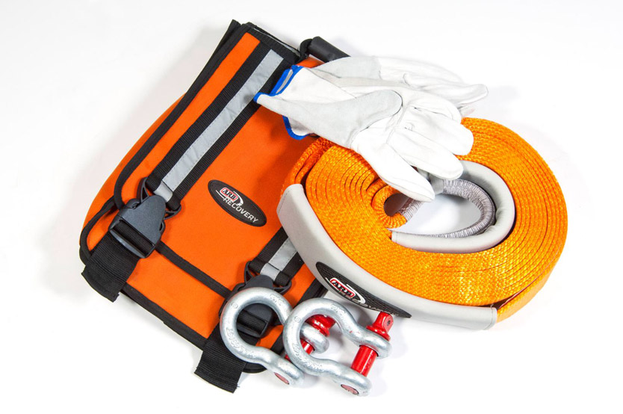
- One carry bag

Template 4.19 E

Winch Recovery Accessories
- One 8,000kg snatch strap
- One 12,000kg tree trunk protector
- One 4,500kg winch extension strap
- One snatch block
- Two 4,750kg bow shackles (19mm, 3/4inch)
- A pair of leather gloves
- One recovery damper
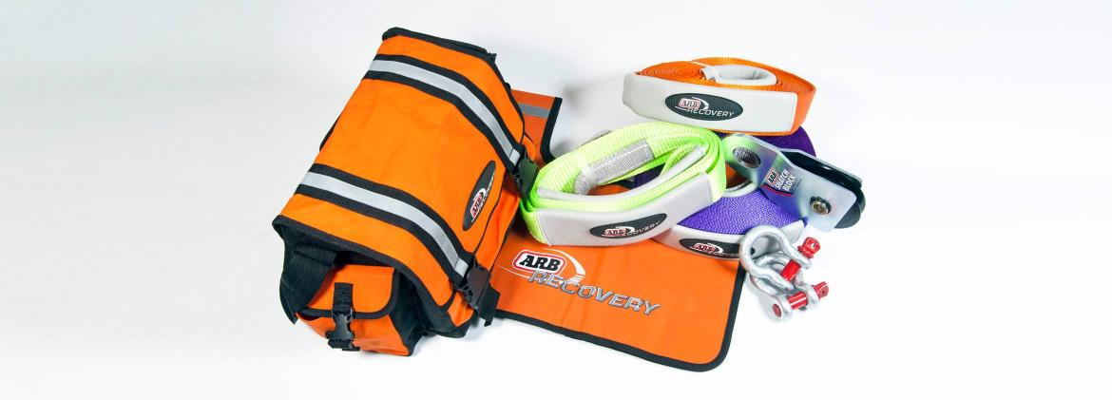

Template 4.19 F
Manual Recovery Package
- Hand winch
- Front and rear recovery points (Subject to vehicle applicability)
- Winch recovery accessories bag containing: One 8,000kg recovery strap, two 4,750kg bow shackles, one recovery strap extension, one tree trunk protector, one snatch block, one cable damper and a pair of leather gloves
- Sand mats (sand ladders)
- Folding shovel

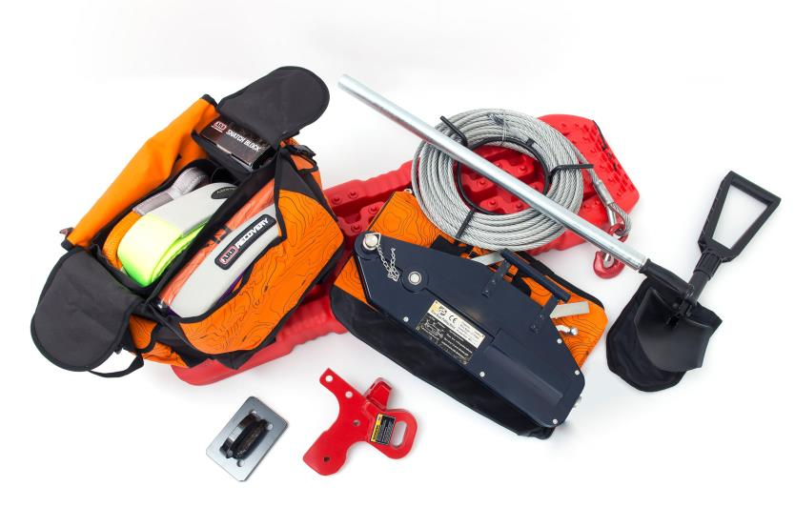

Template 4.19 G

Hand Winch
- Made from high quality steel and aluminium components
- Pulling capacity - 2,400kg
- Rated lifting Capacity - 1,600kg
- Dimensions - 545x280x97mm
- Stainless steel 20m cable
- Cable diameter - 11mm
- Handle length closed - 800mm
- Handle length extended - 1,200mm
- Heavy duty canvas bag
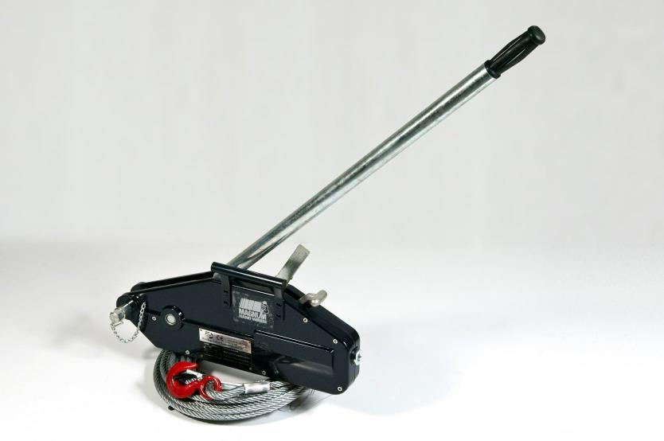

Template 4.19 H

Electric Winch
- Rated line pull: 4,536 kg (10,000lbs) single-line
- 12V series wound motor
- Remote control with wireless capability
- 3-Stage planetary gear train
- Gear ratio: 218:1
- Clutch (free-spooling)
- Synthetic rope: 27.4m, 9.5mm diam. (90 ft, 3/8 in dia.)
- Fairlead: Cast iron hawse
- Powder-coat finish
