Template 4.19 A
Vehicle Tool Kit for Diesel and Petrol Engines
- Slimline 14 Pcs Combination Spanners 6-19mm, to DIN 3113, made from forged CrV steel.
- High quality combination pliers made from forged CrV steel
- Water pump pliers with box joint.
- Flex-dot screwdriver set 8.0x1.2x175mm, 5.5x1.0x125mm, 3.0x0.5x100mm, PH1x80mm and PH2x100mm
- Automotive tester with cable and crocodile clip
- 1/2inch drive socket set (8, 10, 11, 12, 13, 14, 15, 16, 17, 18, 19, 21, 22 & 24mm) made of CrV steel
- 1/2inch drive ratchet with neoprene grip
- 1/2inch drive universal extensions 125 & 250mm
- 1/2inch T-bar
- Spark plug sockets 16, 18 & 21mm – Petrol Only
- Allen key set (1.5, 2, 2.5, 4, 5, 6 & 8mm)
- Torx key set (T-9, T-10, T-15, T-20, T-25, T-27, T-30 & T-40)
- 300g riveting hammer with non-slip graphite handle
- Heavy Duty Gloves
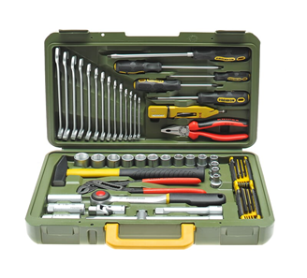
- LED torch/powerbank

Template 4.19 B

Advanced Vehicle Tool Kit for Diesel and Petrol Engines
As above plus:
- Inner-tube repair kit
- 2 tyre levers 600mm
- Tyre pressure gauge
- Heavy Duty Jump Leads
- Wheel Wrench
- Foot Pump
- High Lift Jack
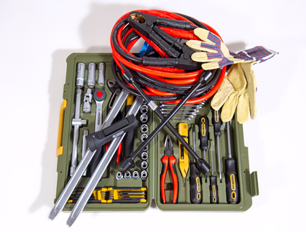

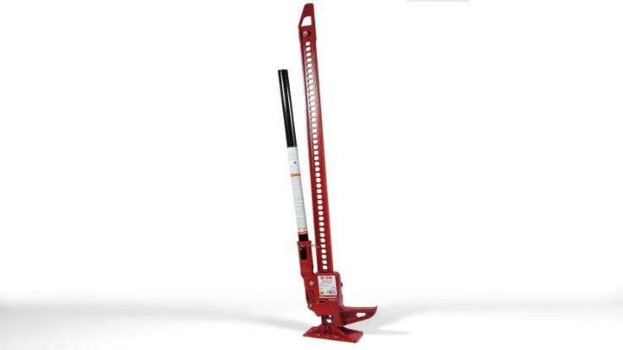

Template 4.19 C

Basic Workshop Tool Kit
- Heavy Duty Bottle Jack
- Axle Stands
- Heavy-duty booster cables 600A 25mm²x5m
- 12 LED cordless rechargable inspection light
- 220mm funnel with closing lid
- 3-piece wire brush set
- Oil wrench band type 65 - 105mm
- 2lb ball-pein hammer with hickory handle
- 21-piece screwdriver set
- 12-piece combination wrench set (8, 9, 10, 11, 12, 13, 14, 15, 16, 17, 18, 19mm)
- 3-piece adjustable wrench set (150,200 & 250mm)
- 52-piece socket set (1/4- & 1/2-inch drive) metric
- 3-piece pliers set
- 610mm crowbar
- Heavy-duty retracting knife
- Digital multi-meter with thermocouple
- Heavy Duty Gloves
- 30-piece hex key set:
- Long Arm keys (Imperial): 0.028, 0.035, 0.050, 1/16, 5/64, 3/32, 7/64, 1/8, 9/64, 5/32, 3/16, 7/32, 1/4, 5/16, 3/8
- Short arm keys (Metric): 0.7, 0.9, 1.3, 1.5, 2, 2.5, 3, 4, 4.5, 5, 5.5, 6, 7, 8, 10mm
- 300mm professional hacksaw
- 10x bi-metal 300mm hacksaw blades
- Inner-tube repair kit
- 2 tyre levers 600mm
- Steel storage chest
- 12V/24V, 15A, 230V automatic battery charger
- 1m steel workbench with lockable drawer
- 125mm fixed base professional heavy-duty vice
- Oil/Fluid Drain & Recycle Container 16ltr
- Toolbox with six drawers and ball bearing runners

